|  |  |
| --- | --- |
| **OFFICE USE ONLY** | |
| Date: |  |
| Staff: |  |
| Client ID: |  |

 **Request for Young Saheliya Services**

|  |  |  |  |  |  |  |  |  |  |  |  |  |  |  |  |  |
| --- | --- | --- | --- | --- | --- | --- | --- | --- | --- | --- | --- | --- | --- | --- | --- | --- |
| Name: |  | |  | Social Media ID: | | | Twitter:  Facebook: | | |  | | | | |  | |
|  | | | | |
| Address: |  | | | |  | | |  | | |  | |  | | |  |
|  |  | | | | Postcode: | | | | | |  | | | | | |
| Tel: |  | | Email: | |  | | | | | | | | | | | |
| Mobile: |  | | N.I.N.: |  | |  | | |  | | |  | |  | | |
| How to contact: | Phone: |  | Message: | |  | | | Post: | | | | | Email: | | | |

|  |  |  |  |  |  |  |  |  |  |  |  |  |  |  |
| --- | --- | --- | --- | --- | --- | --- | --- | --- | --- | --- | --- | --- | --- | --- |
| Ethnicity: | |  | | Religion**:** |  | | | Nationality: | | | |  | | |
| Language: | |  | | | | | D.O.B.: | | | |  | | | |
| Is this a self referral? | | Yes | | No | Professional Referrals: | | | | | | |  | |
| Are parents aware of the referral? | | Yes | | No | Name of Referrer: | | |  | | | | | |
| (consent required for under 12s ONLY) | |  | |  | Organisation | | |  | | | | | |
| Name of School/College/University: | |  | |  | Contact number: | | |  | | | | | |
|  | |  | | | Contact email: | | | |  | | | |  |

|  |  |  |  |  |  |  |  |  |
| --- | --- | --- | --- | --- | --- | --- | --- | --- |
| **In case of emergency, please contact:** | | | | Name: | | | | |
| Relationship: | |  | | Tel: | |  | | |
| **My GP is Dr.:** |  | | Tel: | | | | | Med. Centre: |
| Address: |  | | | | | | | |
| Health Condition/ Disability: | |  | | | Medication(s): | |  | |

|  |  |  |  |  |  |  |  |  |  |  |  |  |  |  |  |  |  |  |  |  |  |
| --- | --- | --- | --- | --- | --- | --- | --- | --- | --- | --- | --- | --- | --- | --- | --- | --- | --- | --- | --- | --- | --- |
| Has the young person accessed other psychological services? | | | | | | | | | | | | Yes: | |  | | | | No: | |  | |
| Details of service: | | | | | | | Date last seen: | | | | |  | | | | | | | | | |
|  | | | | | | | | | | | |  |  | | | |  | |  | |  |
| **Please give contact information on the Named Person, as well as other key workers involved with the young person (ex. youth worker, social worker, guidance teacher, etc.):** | | | | | | | | | | | | | | | | | | | | | |
| Parental Country of Birth (PCoB) |  |  |  | | | | | | |  |  | | | | | | | | | | |
| *Named Person:* | |  | | *Organisation*: |  | | | Phone number: | | | | | | |  | | | | | | |
| Other Workers: | |  |  | | | | | | |  |  | | | | | | | | | | |
| Name: |  | | | Organisation: | |  | | | Phone Number: | | | | | | |  | | | | | |
| Name: |  | | | Organisation: | |  | | | Phone Number: | | | | | | |  | | | | | |
| Name: |  | | | Organisation: | |  | | | Phone Number: | | | | | | |  | | | | | |

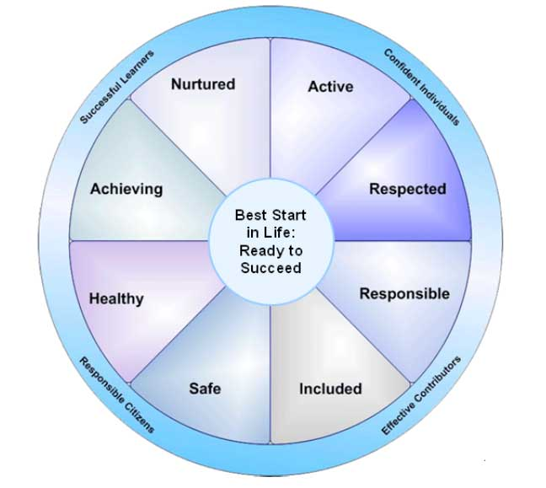**Professional Referrals: Please use the ‘Wellbeing Wheel’ to identify issues and, if appropriate, how the information has been shared and actions taken. Please also summarise any previous concerns:**

|  |  |  |  |  |  |  |  |  |  |  |  |  |
| --- | --- | --- | --- | --- | --- | --- | --- | --- | --- | --- | --- | --- |
| **Other Household Members:** | | |  | |  | |  | |  | |  | |
| Name: |  | Relationship: | |  | | Name: | |  | | Relationship: | |  |
| Name: |  | Relationship: | |  | | Name: | |  | | Relationship: | |  |
| Name: |  | Relationship: | |  | | Name: | |  | | Relationship: | |  |
| Name: |  | Relationship: | |  | | Name: | |  | | Relationship: | |  |
| **Self Referrals:** Please tell us why you would like to access Young Saheliya Services:  Who else have you shared your concerns with  Do we have permission to talk with other professionals. Who? | | | | | | | | | | | | | |
|  | | | | | | | | | | | | | |
|  | | | | | | | | | | | | | |
|  | | | | | | | | | | | | | |
|  | | | | | | | | | | | | | |
|  | | | | | | | | | | | | | |
|  | | | | | | | | | | | | | |
|  | | | | | | | | | | | | | |
|  | | | | | | | | | | | | | |
|  | | | | | | | | | | | | | |
|  | | | | | | | | | | | | | |

|  |  |  |  |  |  |  |  |  |  |  |  |  |  |  |  |  |
| --- | --- | --- | --- | --- | --- | --- | --- | --- | --- | --- | --- | --- | --- | --- | --- | --- |
| **Psychological Health** | | | | | |  |  |  |  |  |  |  |  | |  | |
| Stress |  |  | Eating Disorder | | |  | | Alcohol |  | | Low Mood | |  | | |
| Anxiety |  |  | Depression | | |  | | Flashbacks |  | | Trauma | |  | | |
| PND |  |  | Bereavement | | |  | | Panic Attacks |  | | PTSD | |  | | |
| Phobias |  |  | Other: | | | | | Self Harm |  | | Drugs | |  | | |
|  |  |  |  | | |  | |  |  |  |  |  |  | |  | |
| **Welfare & Wellbeing** | | | | | |  | |  |  |  | **Immigration** | | | | |
| Parenting |  |  | Domestic Violence | | |  | | Employability |  |  | Asylum Seeker | |  | | |
| Carer |  |  | Coercive Control | | |  | | Career Issues |  |  | Refugee | |  | | |
| Child Concerns |  |  | Financial Problem | | |  | | Separation |  |  | Trafficking | |  | | |
| Racism |  |  | Concern for other(s) | | |  | | Divorce |  |  | Slavery | |  | | |
| Bullying |  |  | Academic Issues | | |  | | Advocacy |  |  | Case Pending | |  | | |
| Cyber Bullying |  |  | Housing Issues | | |  | | Other: |  |  | Spousal Visa | |  | | |
|  |  |  |  | | |  |  |  |  |  | Sponsor | |  | | |
| **Physical Health** | |  | **Culture/Community** | | |  |  | **Barriers** | |  |  |  |  | |  | |
| Insomnia |  |  | Community Rel/ship | | |  |  | Isolation |  |  | **Legal/Forensic** | |  | |  | |
| Hypersomnia |  |  | Marital Rel/ship | | |  |  | Religious Divorce |  |  | Child Custody | | |  | |
| Nightmares |  |  | Family Rel/ship | | |  |  | Language Support |  |  | Immigration | | |  | |
| Aches & Pains |  |  | In-law Abuse | | |  |  | Low Confidence |  |  | Court Involvement | | |  | |
| Low Appetite |  |  | FGM | | |  |  | Life Transitions |  |  | Comm. & Lawyer | | |  | |
| Memory Loss |  |  | Forced Marriage | | |  |  | Practical Support |  |  | Legal Repres/tion | | |  | |
| FGM symptoms |  |  | Identity Issues | | |  |  | Literacy Issues |  |  | Legal Aid | | |  | |
|  | | | | |  | | | | | | | | | | |
| **Consider For: Counselling** | | | | **One-to-one support**  **Befriending**  **Group Support** | | | | | | | | | | | |
| **Complementary Therapies**  **Young Saheliya Group**  **School Work** | | | | | | | | | | | | | | | |
| **Consent: I have explained to the Referred Person about Saheliya’s Confidentiality and Record-Keeping policies and she acknowledged this by signing below / I initial on her behalf in her presence.**  **Referred Person: Saheliya Staff : Date:** | | | | | | | | | | | | | | | |

*Please return this form to:*

Saheliya, 125 McDonald Road, Edinburgh, EH7 4NW

Tel: 0131 556 9302; Email: [info@saheliya.co.uk](mailto:info@saheliya.co.uk);