YOUNG SAHELIYA REFERRAL FORM
(AGE 12-25)
OFFICE USE ONLY
Date Referral Received:
Received By(Full Name):
Client ID:
Name: | Have you accessed Saheliya services before?  Yes No
Address:
Postcode:
Phone:  Mobile:  Email: | Age:  DOB:
Preferred method of contact: Phone Message Post Email

Additional Information
Nationality: | Ethnicity: | Religion:
Languages Spoken:
Language Support Required? Yes No

Service Request:
Counselling | 1:1 Support | Group Work | Employability
Family Support | Learning Hub | Comp. Therapies

Referral Made By:
Self Referral |  | Third Party Referral | Relationship:
Name and Address (for third party referrals only): |  |  | Phone:
Reason for Referral:

Crisis Referral Yes No If Yes, please specify:

Date of Referral:

Are there any family or household members currently accessing Saheliya’s services? | Yes No  If Yes please specify:

For Professional Referrals:
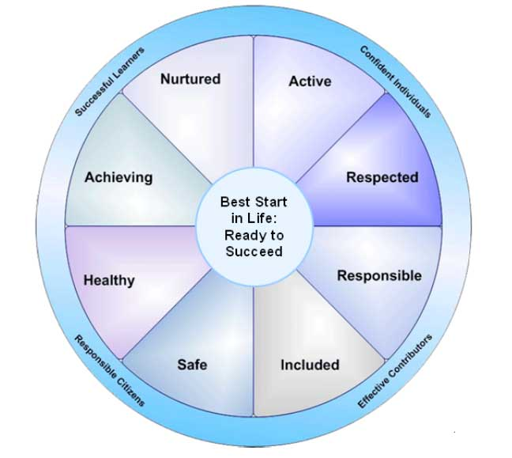
Please use the 'Wellbeing Wheel' headings to highlight your concerns and any identified risks.

Other agencies/ schools involved: (eg Shakti, Social Work, Shelter etc)
Agency: | Key Worker: | Number:
Agency: | Key Worker: | Number:

In case of emergency, please contact: |  | Name:
Relationship: |  | Phone:
Medical Centre |  | Phone:
Address:
Disabilities: |  | Medical Needs:

Anything else you would like us to know:

Please return form to: | Saheliya, 125 McDonald Road, Edinburgh, EH7 4NW
Email: | info@saheliya.co.uk
Phone: | 0131 556 9302

Saheliya is committed to meeting its obligations under the Data Protection Act (1998). Saheliya will hold and process relevant information in order to provide the services that you require. It is the policy of Saheliya to ensure that all data provided by you or the person referring you to the service will be stored securely and checked for accuracy and authenticity as the opportunity arises.
You have the right to access the personal information that Saheliya stores on you, subject to other legal restrictions and third party confidentiality. If you wish to see these details please ask the Manager or Coordinator of the service who will provide you with access to information specific to you. Should you have a complaint regarding the processing of your personal data you should write to the Data Controller, Saheliya, 125 McDonald Road, Edinburgh, EH7 4NW. By consenting to being referred to a Saheliya service and having read the statement above, you are providing your consent for that data to be held and processed.
Further details regarding our privacy policy can be viewed at the following address. www.saheliya.co.uk/saheliya/downloads

