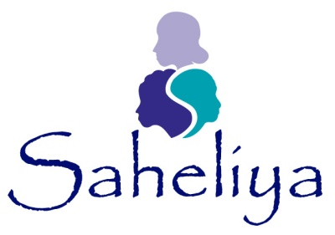

Equality monitoring form

- What was your age last birthday?
- Do you consider yourself to have an illness or disability which has lasted or is expected to last 12 months?
  - No
  - Physical disability
  - Learning disability
  - Mental health
  - Sight loss
  - Blindness
  - Hearing loss
  - Deafness
  - Other substantial and long term condition
If so, what support do you need?
……………………………………………………………. …………………………….
- What is your postcode?

- Which of the following best describes your religious beliefs
  - No religion
  - Christian
  - Buddhist
  - Hindu
  - Jewish
  - Muslim
  - Sikh
  - Other

- Which of the following best describes how you think of yourself?
  - White English / Welsh / Scottish / Northern Irish / British
  - White Irish
  - White East European
  - White other
  - Mixed white / Caribbean
  - Mixed white / African
  - Mixed white / Asian
  - Mixed other
  - Asian or Asian British Indian
  - Asian or Asian British Pakistani
  - Asian or Asian British Bangladeshi
  - Chinese or Chinese British
  - Asian or Asian British other
  - Black British / Caribbean
  - Black British / African
  - Black British other
  - Arab
  - Gypsy or traveller
  - Other –
      - ………………………………………………………………….
- Are you pregnant or have you had a child in the last year?
  - Yes
  - No
Do you have caring responsibilities for
- One or more child(ren) under 5 years old?
- One or more child(ren) over 5 years but under 12?
- One of more child(ren) over 12 but under 16?
- An adult?

